Contact Manager Project Documentation

TEAM ID: SWTID-2026-5625

Team Leader : Abinaya E
Team Member: John Wesley, Archana, Jayaraj

Introduction

The Contact Manager is a backend web application developed using Node.js, Express.js, and MongoDB.
The purpose of this application is to store, manage, update, and delete contact details in a database.
The application performs CRUD operations (Create, Read, Update, Delete) on contact information such as name, email, and phone number.
It uses REST API architecture which allows communication between the client and server through HTTP requests. The main objective of the Contact Manager project is to develop a backend web application that allows users to efficiently store, manage, and organize contact information in a database. This application is designed to demonstrate the implementation of backend technologies and database management using modern web development tools.
One of the primary objectives of this project is to build a backend application using Node.js and Express.js. These technologies help in creating a powerful and scalable server that can handle multiple requests from users. The backend server is responsible for processing client requests and interacting with the database.
Another important objective of this project is to implement CRUD operations (Create, Read, Update, and Delete). These operations allow users to add new contact details, view existing contacts, modify contact information, and delete unwanted records from the database. CRUD operations form the basic functionality of most database-driven applications.
The project also aims to store and manage contact data using MongoDB, a NoSQL database that stores data in a flexible and scalable format. MongoDB allows the application to store contact details such as name, email address, and phone number in the form of documents, making data management simple and efficient.
Another objective is to design and implement RESTful APIs. The application follows REST API architecture, which enables communication between the client and the server using standard HTTP methods such as GET, POST, PUT, and DELETE. This architecture helps in building applications that are easy to maintain, scalable, and efficient.
This project also aims to provide a practical understanding of backend development concepts such as routing, middleware, request handling, and database connectivity. By working on this project, developers gain hands-on experience in building server-side applications and managing data operations.
Furthermore, the project helps in understanding how to structure a backend application properly, manage different routes for different operations, and ensure that data is processed securely and efficiently. It also helps in learning how APIs can be tested using tools such as Postman to verify that the application works correctly.
Finally, the objective of this project is to develop a simple yet effective system for managing contacts that can be extended in the future with additional features such as authentication, search functionality, and user-friendly interfaces.

2. Objectives of the Project

The main objective of this project is to design and develop a Contact Management RESTful API using modern backend technologies. The project focuses on understanding how backend systems work and how data can be stored, managed, and retrieved efficiently using a database. The following objectives describe the goals of the project in detail:
1. To develop a RESTful API using Node.js and Express
The project aims to build a RESTful API using Node.js as the runtime environment and Express.js as the web application framework. This helps in understanding how servers handle client requests and send responses through HTTP methods such as GET, POST, PUT, and DELETE.
2. To store and manage contact information in MongoDB
Another objective of the project is to integrate MongoDB, a NoSQL database, to store contact details such as name, phone number, email, and address. This allows the system to manage structured data efficiently and demonstrates how backend applications communicate with databases.
3. To implement CRUD operations
The project focuses on implementing CRUD operations (Create, Read, Update, Delete). These operations allow users to add new contacts, view existing contacts, update contact information, and delete contacts from the database. This helps in understanding the fundamental operations used in most database-driven applications.
4. To understand backend architecture and API design
Through this project, the developer learns how backend architecture works, including routing, controllers, middleware, and database models. It also provides practical knowledge about designing APIs that follow RESTful principles.
5. To test API endpoints using Thunder Client
The project also includes testing the developed API using Thunder Client, a Visual Studio Code extension used for API testing. This helps verify that each API endpoint functions correctly and returns the expected responses.
6. To gain practical experience in backend development
The project provides hands-on experience in backend development, including server creation, request handling, database connectivity, and API testing. This experience helps in understanding real-world web application development.

3. Technologies Used
Node.js – Runtime environment for executing JavaScript on the server.
Express.js – Web framework for building APIs.
MongoDB – NoSQL database used to store contact information.
Mongoose – ODM library used to interact with MongoDB.
Thunder Client – API testing extension in Visual Studio Code.
Nodemon – Automatically restarts the server during development.

4. System Architecture6666
Client (Thunder Client/Postman)
↓
Express Server (API Routes)
↓
Controller Logic
↓
MongoDB Database

5. Project Folder Structure
contact-manager
│
├── config
│ └── dbConnection.js
├── controllers
│ └── contactController.js
├── models
│ └── contactModel.js
├── routes
│ └── contactRoutes.js
├── node_modules
├── .env
├── package.json
└── server.js

6. Database Design
Collection Name: contacts
Fields:
• _id
• name
• email
• phone
• createdAt
• updatedAt

7. API Endpoints
Create Contact
Method: POST
URL: /api/contacts

Get All Contacts
Method: GET
URL: /api/contacts

Get Single Contact
Method: GET
URL: /api/contacts/:id

Update Contact
Method: PUT
URL: /api/contacts/:id

Delete Contact
Method: DELETE
URL: /api/contacts/:id

8. MongoDB Connection Example
const mongoose = require("mongoose");

const connectDb = async () => {
try {
const connect = await mongoose.connect(process.env.CONNECTION_STRING);
console.log("Database connected");
} catch (err) {
console.log(err);
process.exit(1);
}
};

module.exports = connectDb;

9. Contact Model Example
const mongoose = require("mongoose");

const contactSchema = mongoose.Schema({
name: {
type: String,
required: true
},
email: {
type: String,
required: true
},
phone: {
type: String,
required: true
}
});

module.exports = mongoose.model("Contact", contactSchema);

10. Testing Using Thunder Client
1. Install Thunder Client extension in VS Code.
2. Start the server using: npm run dev
3. Open Thunder Client and create a new request.
4. Use POST, GET, PUT, and DELETE methods to test APIs.

11. Advantages
• Easy contact storage and management.
• Fast database operations using MongoDB.
• Simple REST API architecture.
• Scalable backend design.

12. Future Enhancements
• User authentication using JWT.
• Login and registration system.
• Contact search feature.
• Pagination for large contact lists.
• Frontend interface using React.
13. Functional Requirements:
Following are the functional requirements of the proposed solution.

FR No. | Epic)Functional Requirement | Sub Requirement (Story / Sub-Task)
1 | User Authentication and  Authorization | • User registration with name, email, and password  • User login with email and password  • JWT token generation and management  • Password encryption using bcrypt  • Session management and auto-logout on  token expiration  • Protected routes requiring authentication  • User logout functionality
2 | Contact Management  (CRUD Operations) | • Create new contact with name, email, phone,  notes, and tags  • View all contacts for logged-in user  • View individual contact details  • Update existing contact information  • Delete contact with confirmation prompt  • Validate contact data (email format,  required fields)  • Display contact count and metadata
3 | Search and Discovery | • Real-time search across contact names  • Search by email addresses  • Search by tags  • Case-insensitive search functionality  • Display search results count
4 | Data Validation and Error Handling | • Server-side validation for all API endpoints  • Email format validation  • Required field validation  • Display validation errors to user  • API error handling and user-friendly messages  • Prevent duplicate email registration
5 | Contact Information Management | • Store contact name (required)  • Store contact email (optional, validated)  • Store contact phone number (optional)  • Store contact notes/description (optional,  max 1000 chars)  • Store contact tags (optional, max 10 tags)  • Timestamp for contact creation  • Timestamp for last update
6 | User Profile and Account | • Get current user information endpoint  • User-specific data isolation  • Each user accesses only their own contacts  • User ID association with all contacts
7 | Data Persistence and Storage | • Store user data in MongoDB database  • Store contacts in MongoDB database  • Maintain referential integrity (userId foreign  key)  • Automatic timestamp management  • Database indexing for performance  • Secure password storage (hashed)  • LocalStorage for JWT token on client

-functional Requirements:
Following are the non-functional requirements of the proposed solution.

FR No. | Non-Functional  Requirement | Description
1 | Security | All API requests must be secured using JWT authentication.  The app should prevent unauthorized access to user data. Passwords must  be hashed using bcrypt with salt rounds of 10 or higher. SQL/NoSQL injection attacks should be prevented through input validation and parameterized queries. CORS properly configured to allow only authorized origins. Sensitive data (passwords) never exposed in API responses. HTTPS enforced in production environments.
2 | Reliability | The system should handle errors gracefully without crashing.  Database connections should be resilient with automatic reconnection.  Failed API requests should be handled with appropriate error messages.
3 | Performance | API response times should average under 200ms. Database queries optimized  with appropriate indexing. Client-side rendering should be smooth  (60fps animations). Bundle size kept under 500KB for fast loading.
4 | Scalability | The app should handle increasing numbers of users and contacts efficiently  without performance degradation. The architecture should support future  feature expansion. Should support at least 10,000 concurrent users. Individual  users should be able to store up to 10,000 contacts without performance issues.  Database should scale horizontally
5 | Maintainability | The codebase should be well-organized, documented, and easy to maintain.  Code should follow consistent style guidelines and best practices.  Functions should be modular and single-purpose. Comments should  explain complex logic. API endpoints should be clearly documented.  Database schema should be well-defined. Version control with  meaningful commit messages. Separate development, staging, and  production environments.
6 | Compatibility | The application should work across different browsers and devices. Support for  Chrome (latest 2 versions), Firefox (latest 2 versions), Safari (latest 2 versions),  Edge (latest 2 versions). Mobile support for iOS 12+ and Android 8+. Responsive  design working on screen sizes from 320px to 2560px. No dependency on  specific operating systems. API compatible with different client types (web, mobile,  future integrations).

14. Screenshort:
MONGODB SERVER CONNECTION:

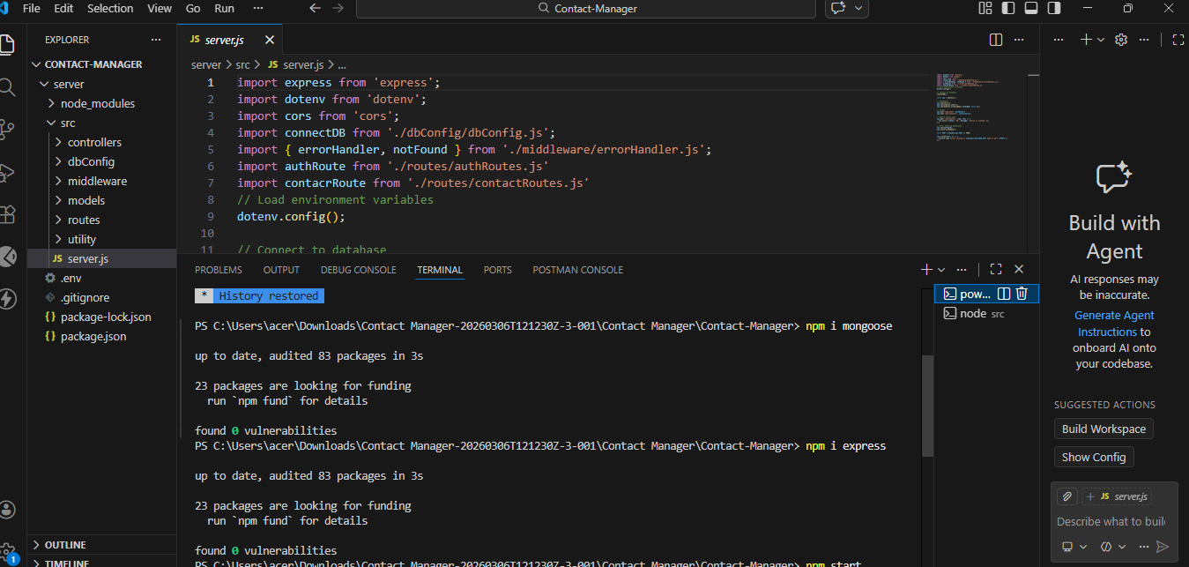

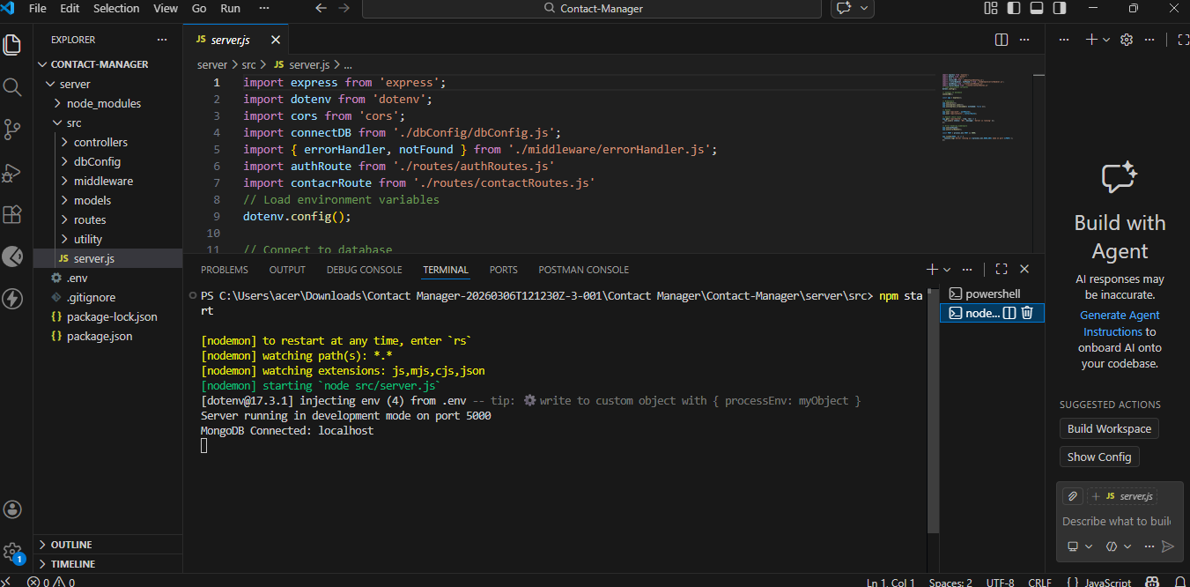

CREATING A CONTACT REGISTER IN THUNDER:

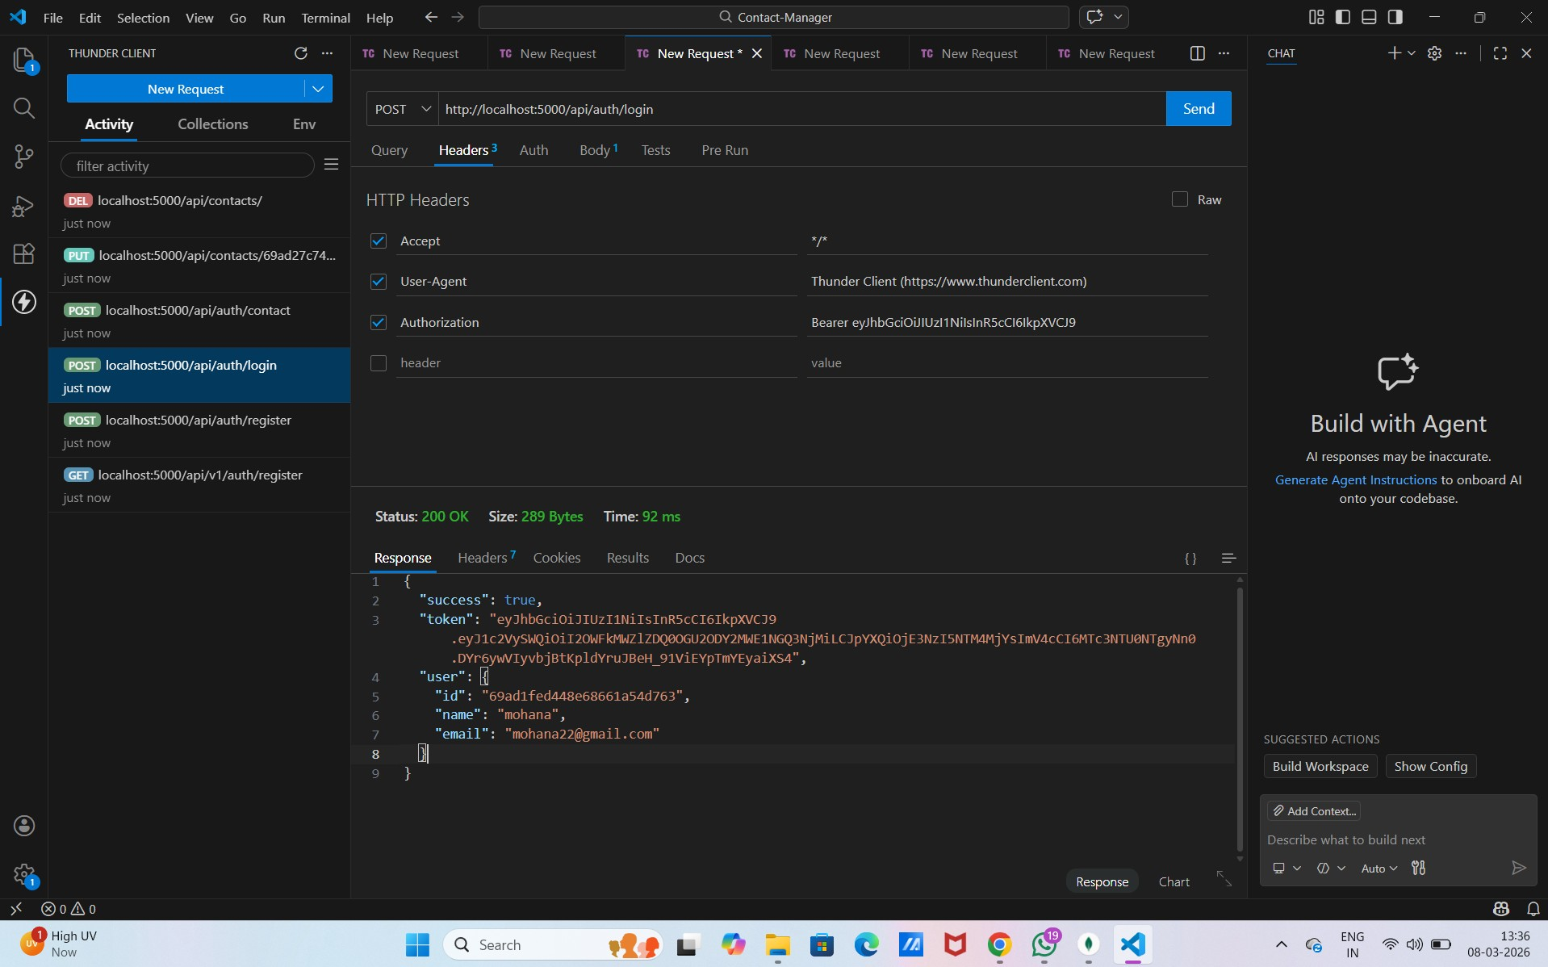

UPDATING CONTACT:

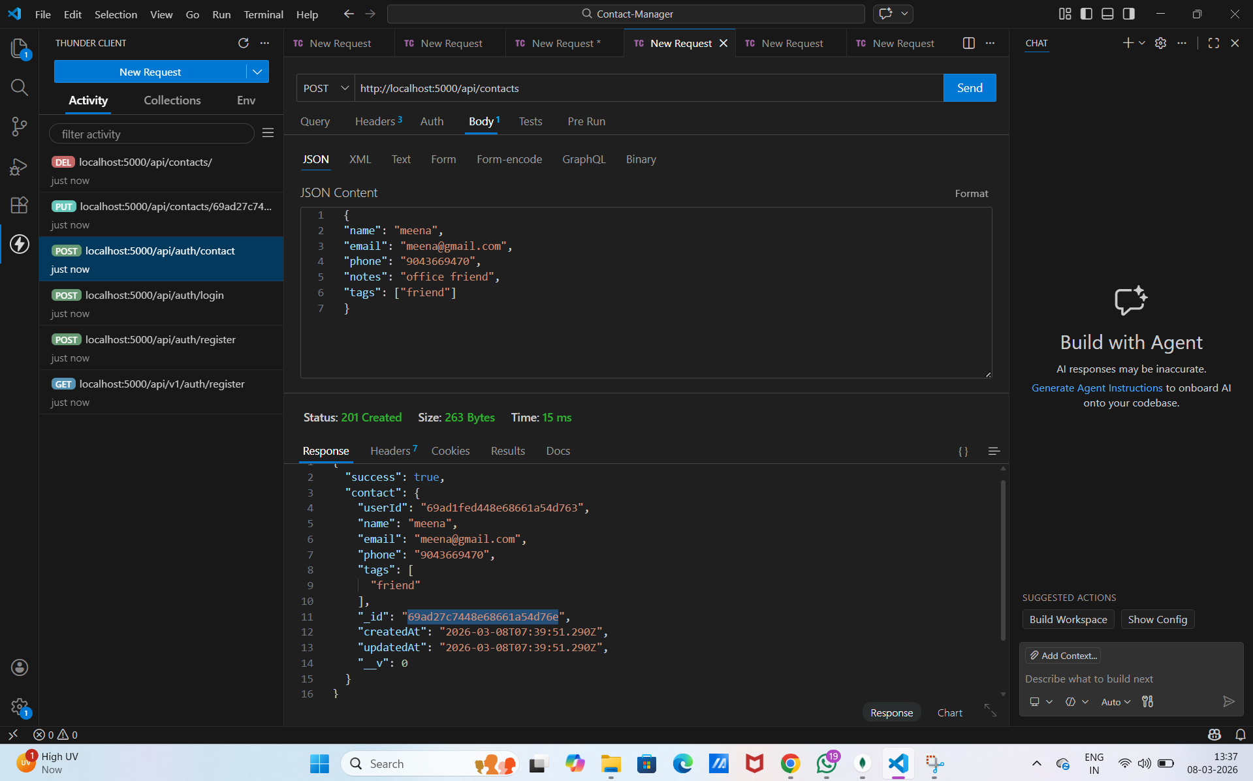
DELETING CONTACT:
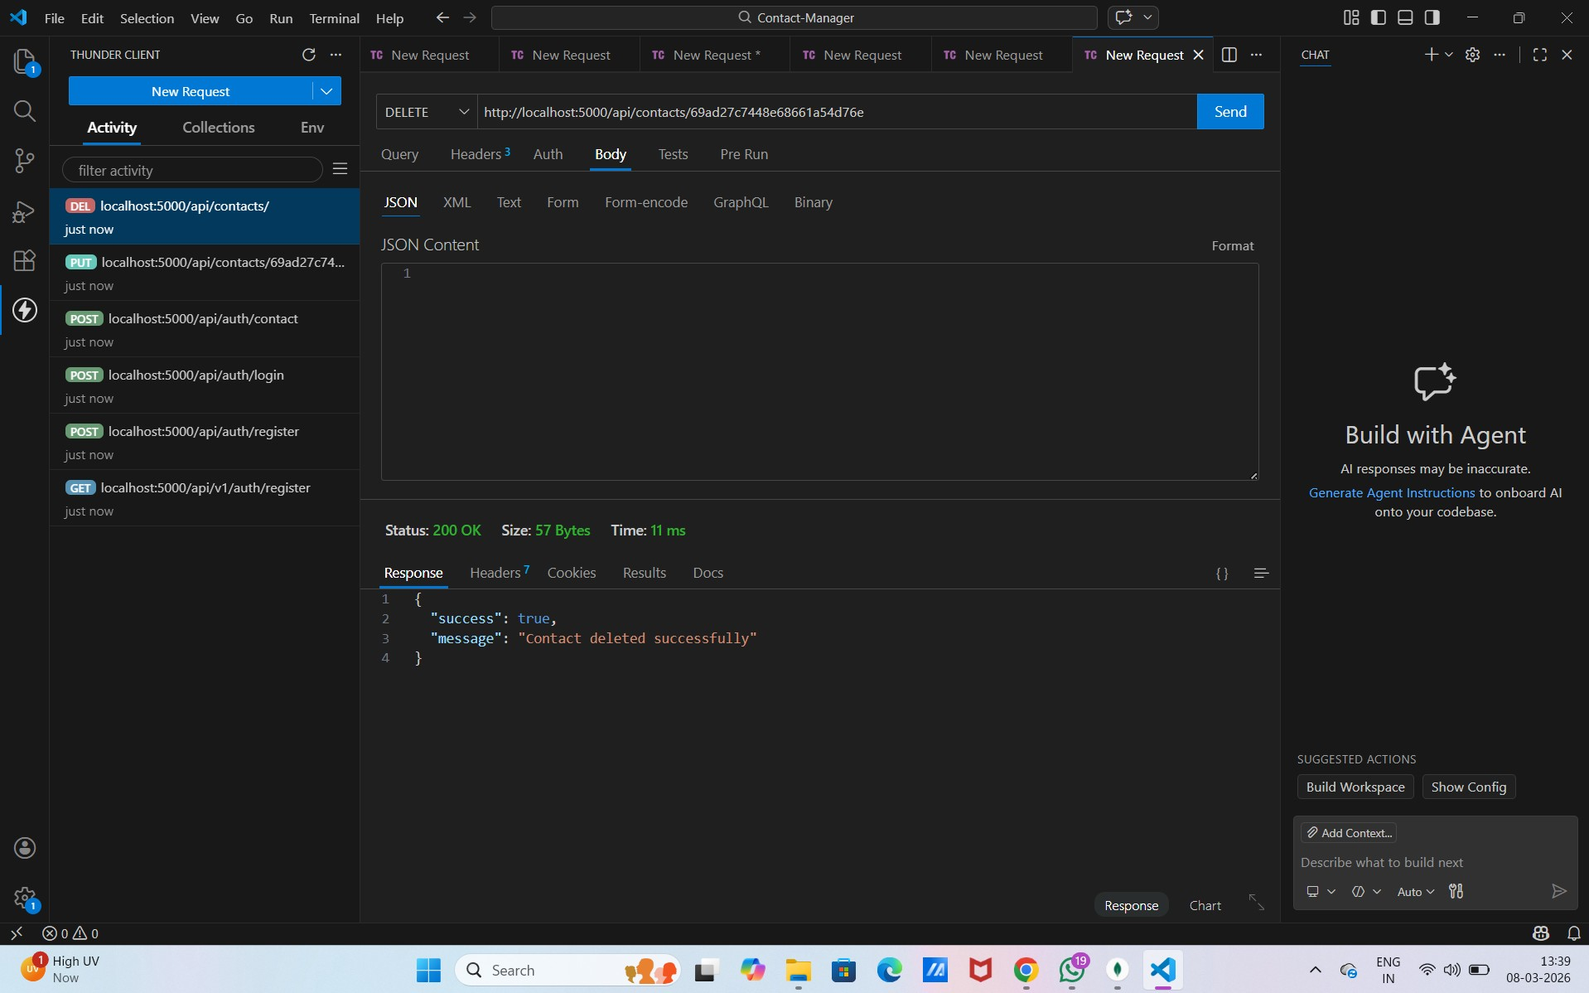

15. Conclusion

The Contact Manager project demonstrates how to build a RESTful API using Node.js and MongoDB. It provides a practical implementation of backend web development concepts and shows how different technologies work together to create a functional server-side application. This project focuses on managing contact information by performing operations such as storing, retrieving, updating, and deleting contact details from a database.
In this project, the server is developed using Node.js, which allows developers to build scalable and high-performance applications using JavaScript. The server handles client requests and sends appropriate responses based on the operation requested by the user. The application also uses Express.js, a lightweight web framework that simplifies the process of creating APIs and managing routes.
Routing plays an important role in this application. It defines different endpoints that allow users to interact with the system. For example, one route may be used to create a new contact, another to retrieve a list of all contacts, another to update an existing contact, and another to delete a contact. Each route corresponds to a specific HTTP method such as GET, POST, PUT, or DELETE.
Controllers are used to manage the logic behind these operations. They act as the bridge between the routes and the database. When a user sends a request to the server, the controller processes the request, performs the required operation, and sends a response back to the client. This structure makes the code organized and easier to maintain.
The project also demonstrates how to perform database operations using MongoDB. MongoDB is a NoSQL database that stores data in the form of documents. Each contact in the database contains fields such as name, email address, and phone number. This flexible structure makes it easy to store and manage different types of data without requiring a fixed schema.
Another important concept used in this project is middleware. Middleware functions help process requests before they reach the controller. They can be used for tasks such as validating input data, handling errors, and managing authentication. Middleware improves the overall efficiency and security of the application.
The application follows REST API architecture, which is widely used in modern web development. REST APIs allow different systems to communicate with each other through HTTP requests. By following REST principles, the Contact Manager application ensures that the API is structured, scalable, and easy to integrate with other applications.
API testing is another important part of the development process. The API endpoints created in this project can be tested using tools such as Postman. API testing helps verify that each endpoint works correctly and returns the expected response. It also allows developers to debug issues and ensure the reliability of the application.
This project also helps developers understand how to structure a backend application in a modular way. Files are organized into folders such as routes, controllers, models, and configuration files. This modular structure improves readability, maintainability, and scalability of the code.
In addition, the Contact Manager project provides practical experience in handling real-world scenarios such as error handling, validating user input, and managing database connections. These concepts are essential for building professional backend systems.
Overall, this project serves as a strong foundation for learning backend development and preparing developers for full-stack application development. By understanding how APIs, servers, and databases interact with each other, developers can extend this knowledge to build more advanced applications with user authentication, front-end interfaces, and additional features.
In the future, this project can be expanded by adding features such as user login and registration, search functionality, contact categorization, and integration with frontend frameworks. These enhancements can transform the Contact Manager into a complete full-stack application.

